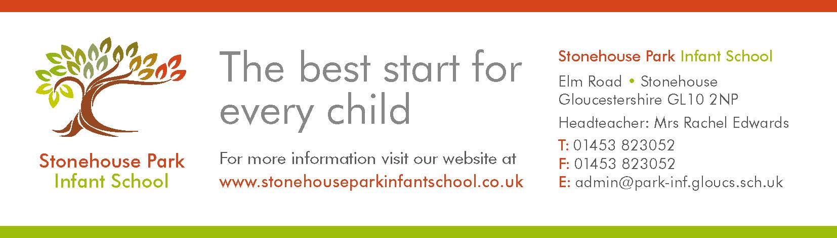

13th March 2020

Dear Parents / Carers

Covid 19

I would like to take this opportunity to remind you of the information attached to our newsletters we have sent to all parents. If possible, please take time to re-read this information and talk to your children about protecting themselves.

We are continuing to receive and review the daily DFE updates that schools receive and will update you if any advice changes.

Here at school we are taking the following additional measures:

* Children are being supervised to wash their hands before starting lessons at school and at key times such as lunchtime, using the DFE/PHE (Public Health England) guidance
* There is plenty of hand wash, tissues and disposable towels for pupils
* Children are reminded and encouraged to wash their hands and sneeze into readily available tissues and then wash their hands as per the DFE/PHE guidance.
* Staff are being vigilant as to the symptoms of Coronavirus and we would ask that you follow guidance from the DFE in the links on the following page.

Much of the above is embedded in our general expectations around hygiene however we will continue to be extremely vigilant due to Coronavirus. We continue to plan for any situation where the Government or DFE instruct schools to close and will stay in touch with any updates to advice received. Please see the page overleaf for the latest advice we have received from the DFE.

Please can I remind you that if you have symptoms and have recently visited an affected area please follow the health advice, stay away from school until you have sought medical advice, and notify us immediately. If a student or staff member presents symptoms at school and has recently visited an affected area, we will arrange for them to be sent home. They should remain at home pending medical advice and follow any actions advised. We ask that the school is kept up to date on advice and actions that you may receive.

Yours sincerely,



Rachel Edwards

Headteacher

## Government coronavirus action plan

The government coronavirus action plan sets out what the UK has done to tackle coronavirus (COVID-19), and what we plan to do next.

The situation is constantly reviewed and action informed by expert science and advice, guided by the Chief Medical Officer and the Chief Scientific Adviser.

**The action plan can be found here:**

|  |
| --- |
| * <https://www.gov.uk/government/publications/coronavirus-action-plan> |

## Action plan recap

The action plan sets out a four-phased approach in response to coronavirus – Contain, Delay, Mitigate, and Research, based on the latest scientific evidence.

The current emphasis is on the Contain and Research phases, however planning for Delay and Mitigation is already in train.

As part of the Contain phase, we have been providing advice to educational settings in England. We also launched a DfE helpline to manage the flow of increasing queries, from providers parents and young people.

## How to wash your hands properly

Wash your hands more often for 20 seconds with soap and hot water.  
Watch this short NHS film for guidance:

|  |
| --- |
| * <https://youtu.be/bQCP7waTRWU> |

**Teach young children how to wash their hands with the NHS handwashing song:**

|  |
| --- |
| * <https://www.youtube.com/watch?v=S9VjeIWLnEg> |

Public Health England recommends that in addition to handwashing before eating, and after coughing and sneezing, everyone should also wash hands after using toilets and travelling on public transport.