Week commencing:18th January
 | Monday | Tuesday | Wednesday |  | Thursday | Friday
Writing | Input from class teacher at 9.30am.  Fact finding –  The Moon Landing – fact finding morning looking at the websites on sheet and making notes. | Input from class teacher at 9.30am.  Writing facts that we have learned about the moon and the Moon landing | Project day.  In a galaxy far away………
Reading | Remember to read with your child every day for 10 minutes.
Phonics | Gp1:  ea – cup of tea  Sheet to be completed (link on sheet)  igh fly high  See link below  Phonics sheet to be completed | Gp1:  oy – toy for a boy  Sheet to be completed (link on sheet)  oa goat on a boat  See link below  Phonics sheet to be completed | Hand writing/tricky word spelling |  | Gp1:  ir – whirl and twirl  Sheet to be completed (link on sheet)  oo poo at the zoo  See link below  Phonics sheet to be completed | Gp1:  ue – blue glue  Sheet to be completed (link on sheet)  oo look at a book  See link below  Phonics sheet to be completed
Maths  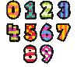 |  |  |  |  | Input from class teacher at 9.30am. Sheet dated 21st Can you name 2D shapes? | Input from class teacher at 9.30am. Sheets dated 22nd Can you name 3D shapes & 3D shape hunt.
Gp1 phonics – links on sheet to be completed

Daily phonics sounds click on the links
igh fly high Mr . Thorne;s Phonics https://www.youtube.com/watch?v=Xj1fge3ylWY
oa goat on a boatMr Thorne’s Phonics https://www.youtube.com/watch?v=tbLTgyrC3eg
oo poo at the zoo Mr Thorne’s Phonics https://www.youtube.com/watch?v=UfMKV_9agiY
oo look at a book Mr Thorne’s Phonics https://www.youtube.com/watch?v=vR47jG-imRo
Tricky words: https://www.youtube.com/watch?v=R087lYrRpgY
Activities to complete throughout the week
Science | Input from class teacher at 9.30am Wednesday  Sheet- seasons wheel. Have a think about the four seasons – which season are we in now? What weather patterns are associated with which season?  Watch this video and have a go at completing your season wheel sheet.  https://www.bbc.co.uk/bitesize/topics/zkvv4wx/articles/zcx3gk7
PE | Try to do a little bit of exercise each day. It will help you stay happy and healthy.  You could start with a wake and shake to get your body moving.  Join The Trolls and dance with ‘Can’t stop the feeling’  https://www.youtube.com/watch?v=KhfkYzUwYFk&list=PLeknmJ9hpclc_LOM4kL7SvzOG1sXaTgvi  Can you make up your own aerobic routine?  You could include sit ups, star jumps, stretches, running on the spot.  Ask someone in your family to join in with you. What moves can they think of? Have fun!
Art | Input from class teacher at 1 pm Thursday  Phases of the moon collage.  You will need 1 sheet of black paper (you could add little white dots to look like stars) and 1 sheet of white paper (you could add crater patterns). Find a small circle to draw around. Cut out 9 circles of each colour. Arrange and stick the black circles onto a piece of paper. Cut the white circles into different size moons and order similar to opposite before sticking them on. |  |  | 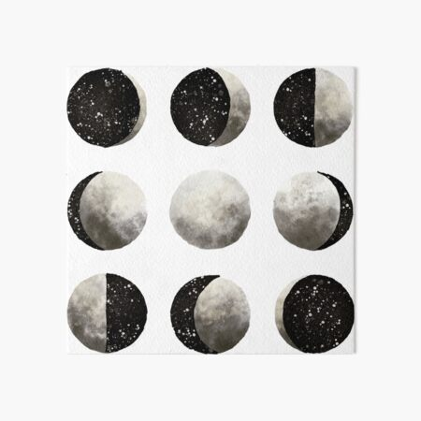
PSHE | STORY – BAG OF WORRIES  https://www.youtube.com/watch?v=8QwEOSBjOt8  Who can we talk to  Brew Monday Cuppa and Chat Mon 18th Jan  Introduce Brew Monday – Some people use a charity called the Samaritans when they are feeling sad or angry or worried about something. When you feel like that the best thing you can do is talk to someone. Who can you talk to about your feelings? Sometimes talking to our friends and family is a good way of sharing our feelings.  Sit and have a cake and a cup of hot chocolate and chat to your families about how you are feeling.  Maybe you could cook some cakes or biscuits together to have a hot drink.  Easy Biscuit recipe https://recipes.sainsburys.co.uk/recipes/baking/easy-biscuits
Music | Sun Moon and Stars Song  https://www.youtube.com/watch?v=vcUyDAO1Fk0  Song Challenge!! Can you learn this song with the people in your house? Start by listening to the song and moving to the music. Then try singing the words one verse at a time. Stop and restart the song whenever you need to. There are some picture clues to help you with the order of the lyrics.  Can you make up your own actions to help you learn the words?
Forest School | Naming and identifying different birds.  What different birds come to your garden?  How might we identify different birds?  Listen to the sounds of birds. Think about their different coloured beaks and feathers.  Can you name the birds that visit?  What food could you put out to encourage them?  Choose one of the birds and draw a picture of it,  Can you label it using these words……..  There is a fun quiz with birds sounds and pictures to test your knowledge (it has quite a lot of british birds so you may want to skip the less common ones!)  https://www.youtube.com/watch?v=0s_sIiWXp84  Next week we will be making a bird feeder so save a couple of yoghurt pots or similar from your recycling. |  |  | 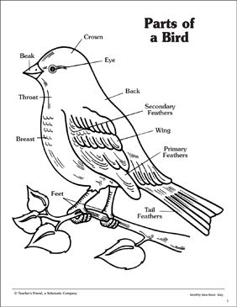
Additional notes:

