Week commencing 03/05/21
 | Learning Objective | Suggested Activities
Literacy | This week we are continuing to learn and explore our new key text ‘Tell Me a Dragon’. | This week, we are going to be completing a plan for a descriptive piece of writing. The writing will be describing our own dragon (being created in art). We will use adjectives and adverbs to describe what the dragon looks like as well as how it moves and what its personality is like.  Here is the link to story read aloud;  Tell Me a Dragon by Jackie Morris - YouTube
Phonics | Please ask your child’s teacher which phase your child is learning or which teacher they are working with if they can’t remember. | Phase 3 (Miss Snell’s group) –  This week, we are learning the sounds ‘oo’ for zoo, ‘oa’ for coat and ‘ar’ for far.  You could practise these words;  Far, star, car  Goat, coat, toast, boat, float  Zoo, poo, boot, scoot, moon.  Phase 3 (Mrs Glew’s) -  This week, we will be recapping all of phase 3 sounds before we move onto phase 5 sounds. You could test your child on these and also practise reading with them to see if they are applying their phase 2 and 3 phonetic knowledge.  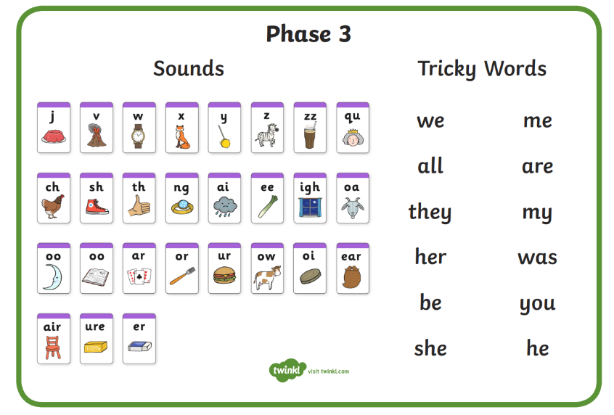  Phase 5 (Mrs Giles’ group) –  This week we will be practising spelling words including all of the alternative ‘ue’ sounds. For example, ‘ue’ and ‘u-e’ (sounds like you) as well as the alternative spellings for the sound ‘oi’ such as ‘oy’.  Which words can you think of? Can you write them in a sentence?  Phase 5/6 (Mrs Walker’s group) –  This week we will be practising making words plural by adding ‘s’, ‘es’ ‘ves’ or ‘ies’. Can you practise some of these at home?
Maths | Subtraction | This week we are going to recap subtraction. Some children will do this with two one-digit numbers, some will move onto taking a one-digit number from a two-digit number, and others will practice taking one two-digit number from another.  Here is a useful video to help the children remember what subtraction involves;  What is subtraction? - BBC Bitesize  We will be recording our workings and drawing lines and dots as ten sticks and ones then crossing out lines and dots accordingly.
Science/Forest School | Plants – parts of a plant and growth | We have planted our own seeds and bulbs and set up an experiment to learn about the condition plants need to grow well.  This week, we will be observing their growth and recording our findings.  You could discuss at home/write down what a plant needs to grow well. You could think about the different parts of a plant too!  Here are some useful links to recap what we have learnt about plants so far;  *What plants can you find outside?  https://www.bbc.co.uk/bitesize/topics/zpxnyrd/articles/zw2y34j  *What are the parts of a plant?  https://www.bbc.co.uk/bitesize/topics/zpxnyrd/articles/z3wpsbk  *What do plants need to grow? https://www.bbc.co.uk/bitesize/topics/zpxnyrd/articles/zxxsyrd  *Talk about the lifecycle of a plant https://www.bbc.co.uk/bitesize/topics/zpxnyrd/articles/z2vdjxs  *Grow your own plants https://www.youtube.com/watch?v=Lly75dEbXE8  *Growing seeds clip https://www.bbc.co.uk/bitesize/clips/zc62tfr
Art | Designing and drawing a dragon | This week we will be drawing our own dragons inspired by our key text ‘Tell Me a Dragon’. We will draw them with pencil first and then choose our favourite medium such as chalk, pastel colours or paints to add colour to it.  The children can choose whether they want to draw these independently or following this YouTube video;  How To Draw A Dragon - YouTube
PE | This term, we are focusing on team games. | Firstly, we will be doing various paired and team activities in order to build trust and practice working as a team.  We will be playing different team games such as, ‘rob the nest’, ‘dishes and domes’, ‘space trash’ and ‘dodgeball’. This will help us to understand how to be a good team player and talk about team tactics.  We are also enjoying Cosmic Kids Yoga to warm up and stretch and well as practising dances such as ‘Just Dance’, ‘Go Noodle’ and ‘Kids Bop’ on YouTube.
Please continue to read your reading books at home and bring them back to school on a Monday and a Friday to be changed where possible.

