Week commencing 15/03/21
 | Learning Objective | Suggested Activities
Literacy | This week we are doing some research into Chris Hadfield the astronaut and author of our key text ‘The Darkest Dark’. | This week we are watching video clips and looking at websites and articles about Chris Hadfield. These are very useful links to find out some information at home;  Chris Hadfield Reading the Darkest Dark with his pug!- https://www.youtube.com/watch?v=sxoG6Eug7jI  Read Aloud (Story Time with Rocket)- https://www.youtube.com/watch?v=riLC81PZ1_8  Chris Hadfield Space Kitchen- https://www.youtube.com/watch?v=AZx0RIV0wss  Chris Hadfield Brushes his teeth in space- https://www.youtube.com/watch?v=3bCoGC532p8  Chris Hadfield Sleeping in space- https://www.youtube.com/watch?v=UyFYgeE32f0  The Darkest Dark song- https://www.youtube.com/watch?v=unQyefH2M2k  https://www.youtube.com/watch?v=nGg30p1UNVI  Information- https://www.bbc.co.uk/programmes/profiles/2Lr802gqK9zQNtGWdMfSZT8/commander-chris-hadfield  Newsround- https://www.bbc.co.uk/newsround/30396719  Chris Hadfield Records song in Space- https://www.bbc.co.uk/newsround/22506830  Facts about Chris- https://kids.kiddle.co/Chris_Hadfield  From the information that we have gathered about Chris Hadfield we are going to be putting together a fact file plan and making a mind map including lots of different facts about him.
Phonics | Please ask your child’s teacher which phase your child is learning or which teacher they are working with if they can’t remember. | After the school being closed, we are focusing on re-assessing the children to see where they are in their learning.  We are completing individual reading and phonics assessments. So, at home in order to support your child you could revisit the sounds and tricky words from their specific phase/group.  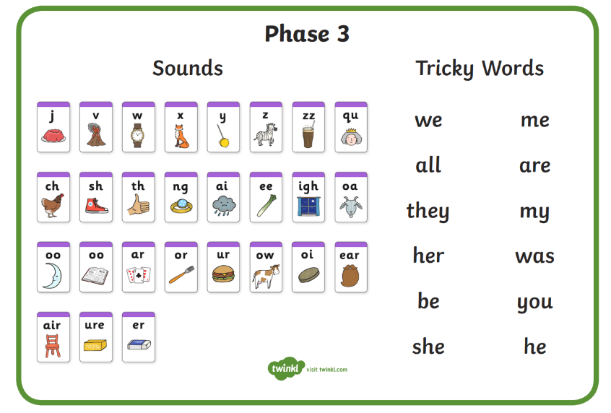  Phase 3 (Mrs Glew’s and Miss Snell’s group) –  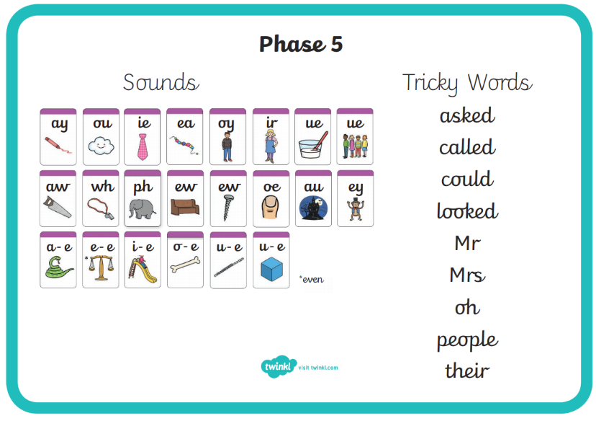  Phase 5 (Mrs Giles’ group) –  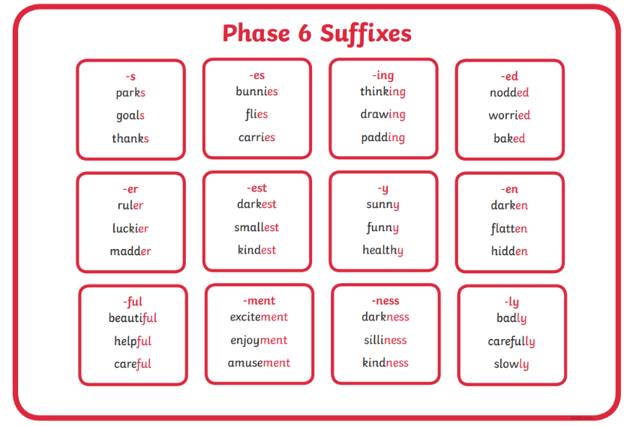  Phase 5/6 (Mrs Walker’s group)-
Maths | This week, we are recapping multiplication. | This week we are recapping multiplication, we use the vocabulary ‘groups of’ or ‘lots of’ to help the children grasp this concept. At home you could practice counting in 2’s, 5’s, 10’s and 3’s.  Here are some videos that the children like to count alongside;  The Counting by Twos Song | Counting Songs | Scratch Garden - YouTube  Count by 5's | Exercise and Count By 5 | Count to 100 | Counting Songs | Jack Hartmann - YouTube  The Counting by Tens Song | Counting Songs | Scratch Garden - YouTube  Counting by 3s - YouTube  You could also practice some number sentences such as;  2x2=  2x5=  4x5=  6x10=  We are practicing recording our workings and drawing dots in arrays as our written method to work out the sums.  Here is a some useful link to support the teaching of this concept;  How to multiply using an array - BBC Bitesize
Science | This week, we are conducting an experiment in order to find out what material would be best to make a space glove out of. | Find out more about spacesuits: https://www.nasa.gov/feature/spacewalk-spacesuit-basics  Gloves  Astronauts must be able to work with and pick up objects while wearing spacesuit gloves. Gloves protect astronauts from the space environment and are made so spacewalkers can move their fingers as easily as possible. The fingers are the part of the body that gets coldest in space, and the gloves on spacesuits are equipped with heaters to keep fingers warm while still allowing dexterity to use tools.  Suitability for a space glove test  The space glove would need to keep the astronaut warm and they would need to be able to pick up ice/rocks/sand etc and be able to work.  We are conducting an experiment to find out which material would be best to make a space glove out of.  You will need;  Four plastic cups  Ice  Cotton Wool  Paper  Foil  To set up –  Put ice into each of the 4 cups  Place foil into one of the cups with the ice  Place paper into one of the cups with the ice  Place cotton wool into one of the cups with the ice  Leave one cup empty  Predict which one you think will melt the ice the slowest/quickest!  Set a timer and record how long it takes for the ice to melt in each of the cups. Which material would give the best insulation for a space glove?
Geography/Forest School | This week, we are thinking about saving our planet. | This week we are thinking about how to look after our environment. We are talking about reducing, reusing and recycling and discussing the benefits of this on the environment.
RE | This week, we are thinking about being thankful and what we are thankful for. | This week, we are thinking about being thankful. We are writing about what we are thankful for in our lives.
Art | This week, we are creating solar system art work. | 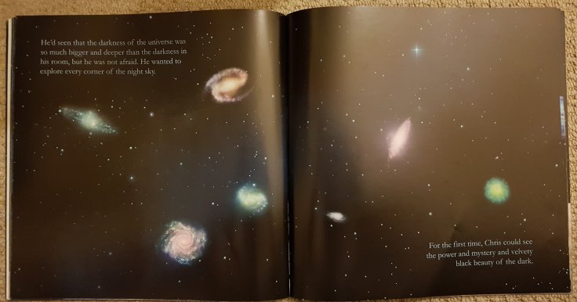  We are creating solar system art work inspired by our key text ‘The Darkest Dark’. We are looking at some famous artists work, such as Kandinsky and Jackson Pollock to get ideas for our own work. We will use different shapes and colours to create the different planets.  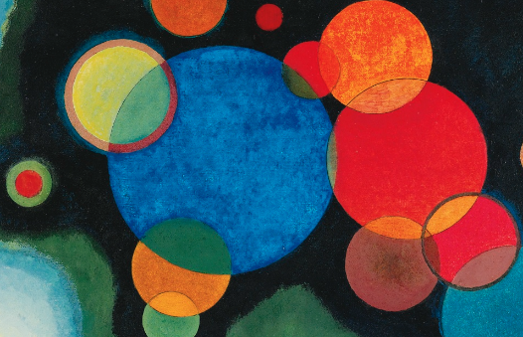  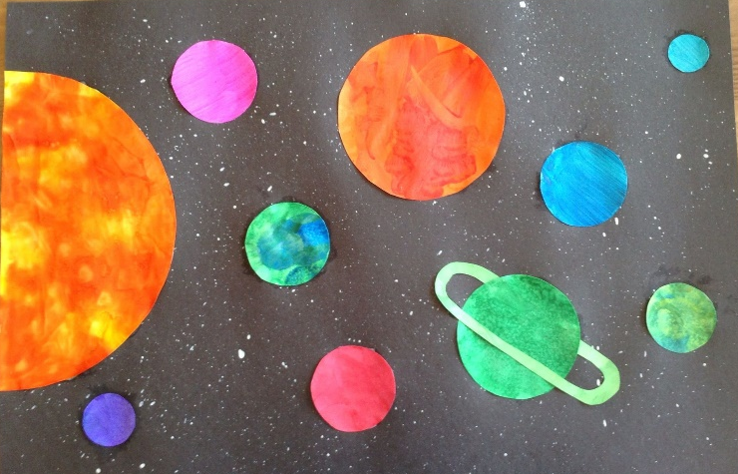  Here is an example piece of work –  You could use resources such as;  Apron/old t shirt  Large black paper  Chalk pastels  Bright colour paints  Watercolours  Small brushes  White card circles  Glitter  Step One – Create a background. We are going to flick colourful paint using paint brushes onto plain black paper  Step Two – Using 8 different pieces of plain white circular card/paper, create each planet using colourful chalks or paints.  Step Three – stick down the planets using glue
PE | This term, we are focusing on gymnastics and dance. | We are learning to master gymnastics movements such as;  Shapes – tuck, straddle, pike, pencil, star, happy/sad cat, front/back supports  Rolls – pencil/log roll, forward roll (rolly polly), teddy bear roll  We will be using these gymnastics shapes, rolls and travelling movements to create a sort piece of dance. We will be linking this to our key text ‘The Darkest Dark’ by following a space theme.  We will create a whole class piece of movement then add to this in pairs and then in groups of 4 before performing this to the rest of our class mates.  We will be creating and performing the dance to the Star Wars theme tune;  Star Wars Main Theme (Full) - YouTube  We are also enjoying Cosmic Kids Yoga to warm up and stretch and well as practising dances such as ‘Just Dance’, ‘Go Noodle’ and ‘Kids Bop’ on YouTube.

