Week commencing:22nd February
 | Monday | Tuesday | Wednesday |  | Thursday | Friday
Writing | Children to write their own innovated story of Man on the Moon  To write a short story using prompts from previous week  To write a sentence to go with each picture  To write a sentence to go | Design an Alien and give it a name!
Reading | Read for 10 minutes daily with your child. Don’t forget to talk about and question the things that happen in the story. | https://home.oxfordowl.co.uk/reading/free-ebooks/  Free E books on Oxford Reading Owl lots of choice for extra reading practise at home. | https://home.oxfordowl.co.uk/reading/free-ebooks/  Free E books on Oxford Reading Owl lots of choice for extra reading practise at home. |  | Read for 10 minutes daily with your child. Don’t forget to talk about and question the things that happen in the story. | Read for 10 minutes daily with your child. Don’t forget to talk about and question the things that happen in the story.
Phonics | Phase 3 Revision Sheet - Practise saying, reading and writing the sounds in words.  Sheets in Pack  Phase 5 sound  e-e –  Pete and Steve song  https://www.youtube.com/watch?v=O71-Ih-DKLU  Sheet in Pack | Phonics Games Day!!  I spy  Read and Roll  Have a go at some Phonics games on line :www.phonicsplay.co.uk/user: jan21 password: home  i-e – nice smile  Mike the pike song  https://www.youtube.com/watch?v=vDms5bRsvq4  Sheet in Pack | Handwriting  Sheet in pack  Have a go at some Phonics games on line :www.phonicsplay.co.uk/user: jan21 password: home |  | Phase 3 Revision Sheet - Practise saying, reading and writing the sounds in words. Writing tricky words.  Sheets in Pack  o-e –  Cole the mole song  https://www.youtube.com/watch?v=gC1fTHlWLOI  Sheet in Pack | Sentence sheet  Sheet in pack  u-e – huge brute  Jude the mule song  https://www.youtube.com/watch?v=x-H4SezDuo4  Sheet in Pack
Maths  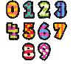 |  |  |  |  | Input from class teacher at 9.30am.  Sheet dated Thursday 25th Place Value | Input from class teacher at 9.30am.  Sheet dated Friday 26th Place Value 2
Activities to complete throughout the week
Science | Input from class teacher at 9.30am on Wednesday.  We will be learning what a carnivore, omnivore and a herbivore is.  Watch this video clip:  https://www.bbc.co.uk/bitesize/clips/zwfd2p3  Sheet ‘Carnivore, omnivore or herbivore?’. Cut and stick the animals into the correct group according to what they eat.  After, you could have a go at this quiz:  https://www.educationquizzes.com/ks1/science/animals-carnivores-herbivores-and-omnivores/
PE

Art | Making dinosaur skeletons.  Be creative and make up your own dinosaur. Can you give it a name?  Have a look at the skeleton examples in your learning pack. Can you describe different parts of the dinosaur?  Try to use specific vocabulary to describe the different parts e.g platelets, spine, ribs, shin, hip etc  Using a white pencil, lightly draw out dinosaur design onto your black piece of paper and then with white paper and scissors, start to add bone detail. |  |  | 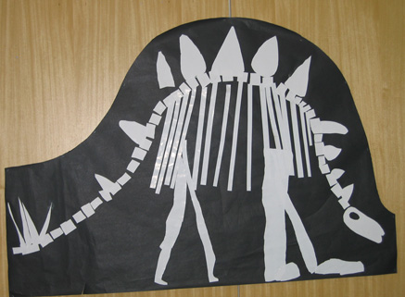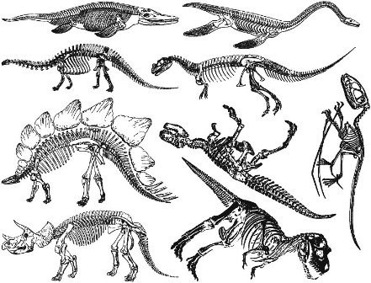
PSHE | Topic this term: My Health ( Science and PE links)  We will be thinking about all the ways we can keep our Body and Minds healthy.  This week we are looking at Physical Activity and how it helps keep us healthy and the affects it has on our bodies.  Sheet 1 : Can you tick the captions that are true about how we feel when we are active. Can you draw on the body what happens to different parts of our body when we are physically active?  Sheet 2 : Challenge for the week . Draw pictures or add photos of the different ways you are active throughout the week.
Music | Spring Songs!!! Here are some songs for you to learn the words to at home. Hopefully we will have the chance to sing them together sometime soon!!!  Spring in My Toes https://www.youtube.com/watch?v=Nfr-1HXF3O0  A Tiny Seed was Sleeping https://www.youtube.com/watch?v=095uO129XFs  And a song to keep you perked up and looking forward to good times ahead  Give a Little Smile https://www.youtube.com/watch?v=DYedaETbsBI
Forest School  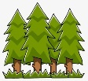 | Looking for signs of Spring  We are looking for signs of spring all around us, at school and at home.  Can your child name the four seasons and tell you which one comes after Winter? How can we tell that spring is on its way? What’s happening to weather? The daylight?  If possible, go for a walk and look around for signs of spring. You could also do this in your garden.  Maybe there are also smells and sound that are spring like too. See how many things you can tick off the list. |  |  | 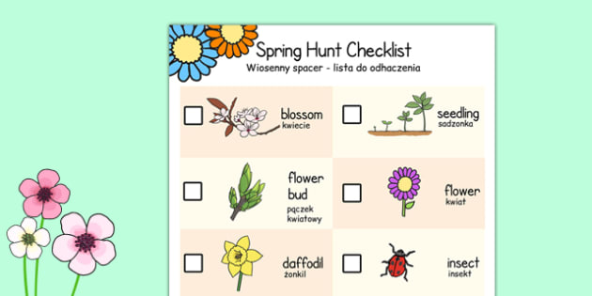
Additional notes:

