Week commencing 10/05/21
 | Learning Objective | Suggested Activities
Literacy | This week we are continuing to learn and explore our new key text ‘Tell Me a Dragon’. | This week, we are going to be using our writing plans from last week to write up our descriptive piece about the dragons that we have created ourselves.  We will use adjectives and adverbs to describe what the dragon looks like as well as how it moves and what its personality is like.  Here is the link to story read aloud;  Tell Me a Dragon by Jackie Morris - YouTube
Phonics | Please ask your child’s teacher which phase your child is learning or which teacher they are working with if they can’t remember. | Phase 3 (Miss Snell’s group) –  This week, we will be learning the sounds ‘or’ for torch, ‘igh’ for night and ‘ur’ for nurse.  You could practise these words;  Fork, torch, porch and for  Night, light, fight, bright and high  Nurse, purse and fur  Phase 5 (Mrs Glew’s) -  This week, we will be starting to learn phase 5 sounds. Starting with the sounds;  ‘ay’ for play and ‘ou’ for proud. The children will be comparing these to phase 3 sounds that they already now e.g. ‘ai’ for oil and ‘ow’ for cow.  You could practise reading this sound in some words such as;  day, play, May, today, stay, clay  out, cloud, proud, found, sound, ground, loud  You could also recap phase 3 sounds and test your child on these whilst reading with them to see if they are applying their phase 2 and 3 phonetic knowledge.  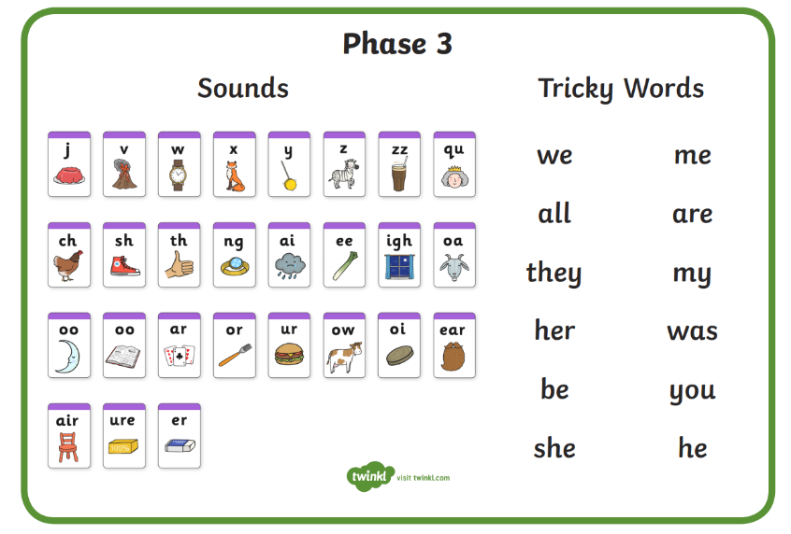  Phase 5 (Mrs Giles’ group) –  This week we will be practising spelling words including all of the alternative ‘ar’ sounds. For example, ‘ar, ‘al’ and ‘a’ as well as the alternative spellings for the sound ‘o’ such as ‘o’ for dog and ‘a’ for wasp.  Which words can you think of? Can you write them in a sentence?  Fo example;  ‘ar’ – car, far, marble, hard, Mars, bar, spar, star, scarf, card, jar  ‘al’ – half, calf, behalf, calm, palm,  ‘a’ - bath, path, daft, craft, draft  ‘o’ – dog, fog, log, frog, smog, jog, dot, spot, stop,  ‘a’ - wasp, what, wash, wand, watch, squad, squat, squash  Phase 5/6 (Mrs Walker’s group) –  This week we will be continue practising making words plural by adding ‘s’, ‘es’ ‘ves’ or ‘ies’. Can you practise some of these at home?
Maths | Addition and Subtraction | This week we are going to recap both addition and subtraction. Some children will do this with two one-digit numbers, some will move onto taking a one-digit number from a two-digit number, and others will practice taking one two-digit number from another.  We will also be looking at the inverse operations e.g.  2+8=10  8+2=10  10-2=8  10-8=2  Here are some useful videos to help the children remember how to add and subtract and then work out the inverse number sentences;  Addition and subtraction - inverse operations - KS2 Maths - BBC Bitesize  Inverse Operations - YouTube  Adding and subtracting - KS1 Maths - BBC Bitesize  We will be recording our workings and drawing lines and dots as ten sticks and ones then crossing out lines and dots accordingly.
Science/Forest School | Plants – parts of a plant and growth | We have planted our own seeds and bulbs and set up an experiment to learn about the condition plants need to grow well.  This week, we will be observing their growth and recording our findings.  You could discuss at home/write down what a plant needs to grow well. You could think about the different parts of a plant too!  Here are some useful links to recap what we have learnt about plants so far;  *What plants can you find outside?  https://www.bbc.co.uk/bitesize/topics/zpxnyrd/articles/zw2y34j  *What are the parts of a plant?  https://www.bbc.co.uk/bitesize/topics/zpxnyrd/articles/z3wpsbk  *What do plants need to grow? https://www.bbc.co.uk/bitesize/topics/zpxnyrd/articles/zxxsyrd  *Talk about the lifecycle of a plant https://www.bbc.co.uk/bitesize/topics/zpxnyrd/articles/z2vdjxs  *Grow your own plants https://www.youtube.com/watch?v=Lly75dEbXE8  *Growing seeds clip https://www.bbc.co.uk/bitesize/clips/zc62tfr  You could even plant your own bulbs or seeds at home and watch how they grow! You could measure them with a rule over time.
Art | Designing and decorating dragon eggs | This week we will be designing and then decorating our own dragon eggs inspired by our key text ‘Tell Me a Dragon’.  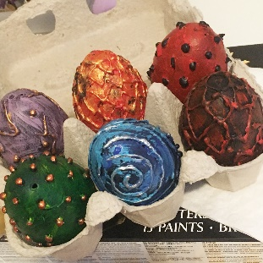  Here are some examples;  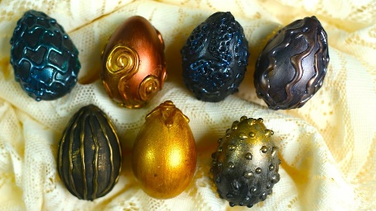  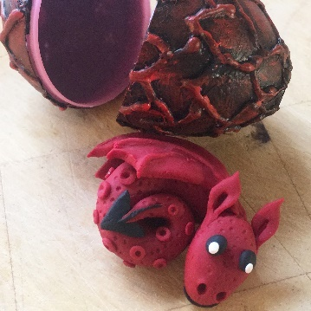  You could even make your own playdough dragon if you have some at home!
PE | This term, we are focusing on team games. | Firstly, we will be doing various paired and team activities in order to build trust and practice working as a team.  We will be playing different team games such as, ‘rob the nest’, ‘dishes and domes’, ‘space trash’ and ‘dodgeball’. This will help us to understand how to be a good team player and talk about team tactics.  We are also enjoying Cosmic Kids Yoga to warm up and stretch and well as practising dances such as ‘Just Dance’, ‘Go Noodle’ and ‘Kids Bop’ on YouTube.
Geography and History | NC: Changes within living memory.  Researching types of castles and finding out about castles in the UK. | This week, we will recap our learning about the four countries in the UK – England, Scotland, Wales and Northern Ireland.  We will then start to look at castles in the UK.  Here are some interesting videos that may help you;  *What is a castle? https://www.youtube.com/watch?v=AesgRREuCQI  *Talk to your child about types of castles, show clip: https://www.youtube.com/watch?v=RXXDThkJ3Ew  *Show your child aerial photos of different castles in the UK  http://www.primaryhomeworkhelp.co.uk/castles/timeline.htm  https://www.castlexplorer.co.uk/  *English heritage- Postcard from different castles https://www.youtube.com/watch?v=f-ZXmfqc0HA&list=PLx2QMoA1Th9eAbra3uPThn3xgi34t5JuL  *Castles through time-  https://www.english-heritage.org.uk/castles/castles-through-time/
Please continue to read your reading books at home and bring them back to school on a Monday and a Friday to be changed where possible.

