Week commencing 17/05/21
 | Learning Objective | Suggested Activities
Literacy | This week, we are editing and refining our dragon description from last week.  Here is the link to story read aloud;  Tell Me a Dragon by Jackie Morris - YouTube | This week, we are going to be editing and redrafting our dragon descriptive piece from last week.  We will be checking for full stops, capital letters and finger spaces. If we have forgotten these anywhere, then we can add them in to correct it.  We will also be looking to edit and add in more exciting vocabulary. For example, we may want to add some more adjectives, adverbs or a simile.  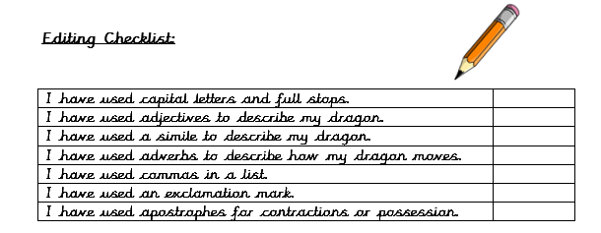
Phonics | Please ask your child’s teacher which phase your child is learning or which teacher they are working with if they can’t remember. | Phase 3 (Miss Snell’s group) –  This week, we will be learning the sounds ‘ow’ for cow, ‘oi’ for boil  and ‘ear’ for hear.  You could practise these words;  Cow, bow and how  Boil, foil, oil, coil, coin  Ear, hear, fear and tear  Phase 5 (Mrs Glew’s) -  This week, we will be continuing to learn new phase 5 sounds. The sounds of the week are alternative ‘ee’ digraphs;  ‘ee’ for teeth, ‘ea’ for bead and ‘ey’ for monkey.  You could practise reading this sound in some words such as;  Teeth, beef, sheet, meet, keep  money, donkey, turkey, trolley  eat, sea, bead, seat, read, heat  Phase 5 (Mrs Giles’ group) –  This week we will be practising spelling words including all of the alternative ‘ear’ sounds. For example, ‘ear, ‘eer’ and ‘ere’ as well as the alternative spellings for the sound ‘or’ such as ‘al’ for walk, ‘aw’ for saw, ‘our’ for pour, ‘oor’ for poor, ‘ore’ for more and ‘au’ for haunted.  Which words can you think of? Can you write them in a sentence?  For example;  ‘ear’ - ear, hear, tear, fear, shear  ‘eer’ – deer, career, steer  ‘ere’ -here, sphere  ‘or’ - fork, cork, stork,  al – talk, walk, chalk  ‘au’ – haunted, taunted,  ‘aw’ – saw, claw, draw,  ‘our’ – pour,  ‘oor’ - floor, door  ‘ore’ – sore, more, chore, shore  Phase 5/6 (Mrs Walker’s group) –  This week we will practising adding the suffixes ’ful’ and ‘less’. Can you practise some of these words at home?  Helpful  Careful  Careless  Helpless  Thankful  Peaceful  Can you think of anymore?
Maths | Time | This week we are going to be learning about time. We will be teaching the children tell the time to o’clock, half past, a quarter past and a quarter to the hour.  Here is a fun little video clip on BBC bitesize;  How to tell the time - BBC Bitesize  At home, you could test your child on these.
Science/Forest School | Plants – parts of a plant and growth | We have planted our own seeds and bulbs and set up an experiment to learn about the condition plants need to grow well.  This week, we will be observing their growth and recording our findings.  You could discuss at home/write down what a plant needs to grow well. You could think about the different parts of a plant too!  Here are some useful links to recap what we have learnt about plants so far;  *What plants can you find outside?  https://www.bbc.co.uk/bitesize/topics/zpxnyrd/articles/zw2y34j  *What are the parts of a plant?  https://www.bbc.co.uk/bitesize/topics/zpxnyrd/articles/z3wpsbk  *What do plants need to grow? https://www.bbc.co.uk/bitesize/topics/zpxnyrd/articles/zxxsyrd  *Talk about the lifecycle of a plant https://www.bbc.co.uk/bitesize/topics/zpxnyrd/articles/z2vdjxs  *Grow your own plants https://www.youtube.com/watch?v=Lly75dEbXE8  *Growing seeds clip https://www.bbc.co.uk/bitesize/clips/zc62tfr  You could even plant your own bulbs or seeds at home and watch how they grow! You could measure them with a rule over time.
PSHE | I am responsible | This week we will be learning about our school value of the term ‘I am responsible’.  Think about what the word responsible means.  Play the song –  (2) Being Responsible | Little Mandy Manners | TinyGrads | Children's Videos | Character Songs - YouTube  Watch these video’s of the stories read aloud -  (2) I Just Forgot by Mercer Mayer - Little Critter - Read Aloud Books for Children - Storytime - YouTube  I Just Forgot by Mercer Mayer  and  (2) I'LL DO IT, TAKING RESPONSIBILITY (BOOK)KIDS READING WITH ENGLISH SUBTITLES - YouTube  ‘I’ll Do it!’ by Brian Moses and Mike Gorgon.  Compare the two stories by discussing questions such as;  The first video – ‘I Just Forgot’ by Mercer Mayer;  Was the character showing that they were responsible? Why?  What could they have done?  The second video - ‘I’ll Do it!’ by Brian Moses and Mike Gorgon;  What did the boy do to show that he was responsible?  How did he make others feel?  What type of characteristics did he have?  What could we take responsibility over?  How could we show that we responsible people?
PE | This term, we are focusing on team games. | Firstly, we will be doing various paired and team activities in order to build trust and practice working as a team.  We will be playing different team games such as, ‘rob the nest’, ‘dishes and domes’, ‘space trash’ and ‘dodgeball’. This will help us to understand how to be a good team player and talk about team tactics.  We are also enjoying Cosmic Kids Yoga to warm up and stretch and well as practising dances such as ‘Just Dance’, ‘Go Noodle’ and ‘Kids Bop’ on YouTube.
ICT and Literacy | Final piece – making a class book | This week, we going to design and make a page of a book for our class ‘Tell Me a Dragon’ story. We are going to choose our favourite sentence from our dragon descriptive piece and type it up. We will then decide on a font, a background and a picture to go with the writing.  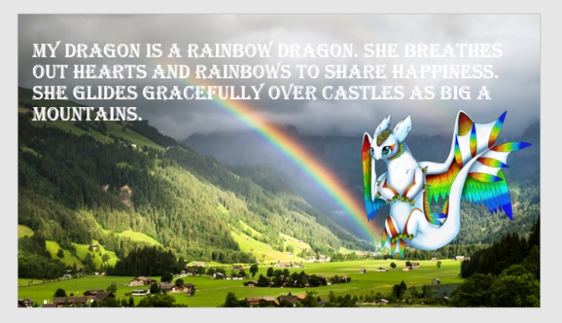  Here is an example;
Please continue to read your reading books at home and bring them back to school on a Monday and a Friday to be changed where possible.

