Week commencing 24/05/21
 | Learning Objective | Suggested Activities
Literacy | 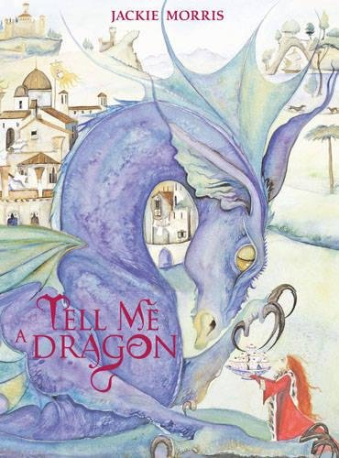  This week, we are comparing two texts. | This week, we are going to be comparing two different texts about dragons.  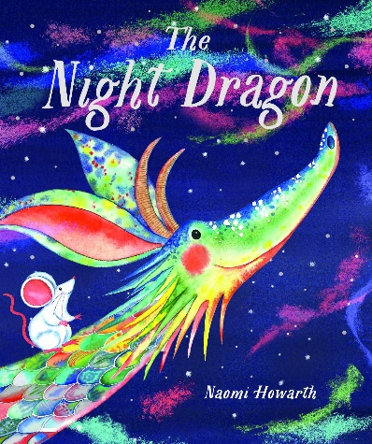  Here are the links to stories read aloud;  Tell Me a Dragon by Jackie Morris - YouTube  The Night Dragon, by Naomi Howarth - YouTube  Have a think about;  What type of text is it? It is a narrative story or like short poems?  What is similar about them?  What is different about them?  What there any similar elements in the illustrations?  Are there any similar dragons?  Are there any similar settings?
Phonics | Please ask your child’s teacher which phase your child is learning or which teacher they are working with if they can’t remember. | Phase 3 (Miss Snell’s group) –  This week, we will be learning the sounds ‘er’ for mixer, ‘air’ for chair, ‘oo’ for book and ‘ure’ for pure.  You could practise these words;  Mixer, her, letter and better  Air, chair, hair, fair and stairs  Sure, pure and cure  Book, cook and shook  Phase 5 (Mrs Glew’s) -  This week, we will be continuing to learn new phase 5 sounds. The sounds of the week are ‘oy’ and ‘ir’ digraphs;  You could practise reading this sound in some words such as;  ‘oy’ - boy, toy, joy, enjoy, royal, annoy  ‘ir’ - sir, girl, bird, shirt, shirt  You could also recap phase 3 sounds and test your child on these whilst reading with them to see if they are applying their phase 2 and 3 phonetic knowledge.  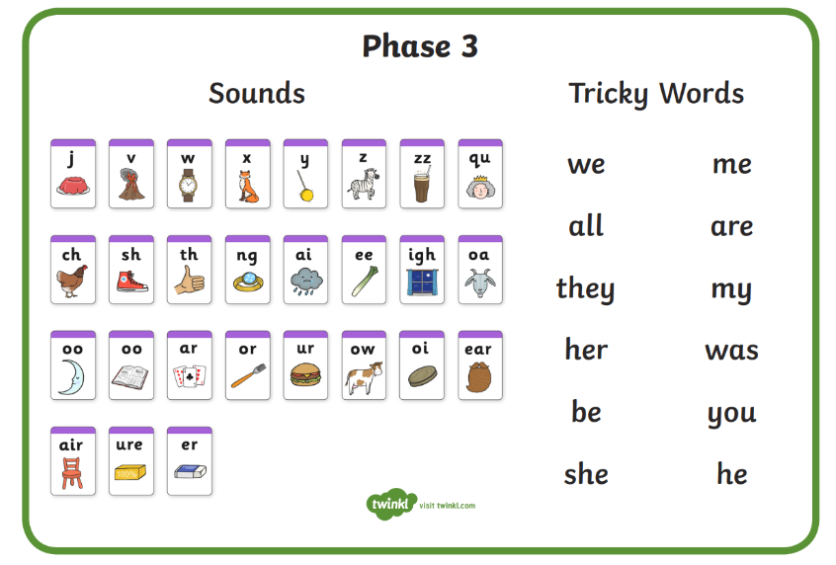  Phase 5 (Mrs Giles’ group) –  This week we will be practising spelling words including all of the alternative ‘oo’ sounds.  Which words can you think of? Can you write them in a sentence?  For example;  ‘oo’ – pool, cool, fool, stool, poo, shoot, zoo, moo  ‘ew’ – crew, threw, chew, blew, grew, flew, screw  ‘ou’ – soup, group, toucan, you, coupon, youth, route, wound  ‘ue’ – glue, blue, true, clue, Sue  ‘ui’ – fruit, bruise, suit, swimsuit, cruise, recruit  ‘u-e’ – flute, rude, rule, prunes  Phase 5/6 (Mrs Walker’s group) –  This week we will continue to practise adding the suffix ‘er’ and ‘est’ to root words.  Here is a little BBC bitesize video about suffix;  What are suffixes? - BBC Bitesize  You could practise words such as;  Smaller  Taller  Happier  Prettier  Smallest  Tallest  Prettiest  Happiest
Maths | Time | This week we are going to continue learning about time and will practice how to tell the time. We will be teaching the children how to tell the time to o’clock, half past, a quarter past and a quarter to the hour.  We will also challenge them by thinking about telling the time to every 5 minutes e.g. 5 past 1, 10 past 1 and so on.  Here are some fun little video clips to help you;  (1) How to Tell the Time - Educational Video for Kids - YouTube  How to tell the time - BBC Bitesize  (1) Hip-Hop Around the Clock | Learn How to Tell Time | Jack Hartmann - YouTube  At home, you could test your child on these.
Science/Forest School (alternate weeks Birch and Lime class) | Plants – parts of a plant and growth | We have planted our own seeds and bulbs and set up an experiment to learn about the condition plants need to grow well.  This week, we will be observing their growth and recording our findings.  You could discuss at home/write down what a plant needs to grow well. You could think about the different parts of a plant too!  Here are some useful links to recap what we have learnt about plants so far;  *What plants can you find outside?  https://www.bbc.co.uk/bitesize/topics/zpxnyrd/articles/zw2y34j  *What are the parts of a plant?  https://www.bbc.co.uk/bitesize/topics/zpxnyrd/articles/z3wpsbk  *What do plants need to grow? https://www.bbc.co.uk/bitesize/topics/zpxnyrd/articles/zxxsyrd  *Talk about the lifecycle of a plant https://www.bbc.co.uk/bitesize/topics/zpxnyrd/articles/z2vdjxs  *Grow your own plants https://www.youtube.com/watch?v=Lly75dEbXE8  *Growing seeds clip https://www.bbc.co.uk/bitesize/clips/zc62tfr  You could even plant your own bulbs or seeds at home and watch how they grow! You could measure them with a rule over time.
PSHE | Loving ourselves and being proud of our achievements | This week, we are thinking about what we love about ourselves and what makes us different to others. We will think about how we can accept everyone, despite our differences and celebrate them.  You could watch these videos at home;  (2) Be Yourself - The Singing Lizard (Song for Children) - YouTube  Show the video of the story read aloud –  (2) The Reflection in Me HD - YouTube  You could discuss with your child;  Did the character love themselves?  What did they do? How did you know?  What did the girl do to show that she loved herself?  How did it make you feel?  What type of characteristics did she have?  How could we love ourselves?
PE | This term, we are focusing on team games. | Firstly, we will be doing various paired and team activities in order to build trust and practice working as a team.  We will be playing different team games such as, ‘rob the nest’, ‘dishes and domes’, ‘space trash’ and ‘dodgeball’. This will help us to understand how to be a good team player and talk about team tactics.  We are also enjoying Cosmic Kids Yoga to warm up and stretch and well as practising dances such as ‘Just Dance’, ‘Go Noodle’ and ‘Kids Bop’ on YouTube.
Please continue to read your reading books at home and bring them back to school on a Monday and a Friday to be changed where possible.

